1. Wikipedia Search Test
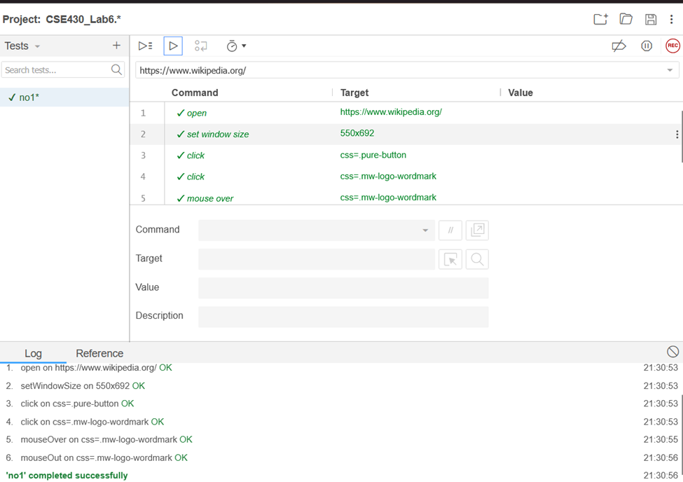

2. Dropdown Test on Booking.com
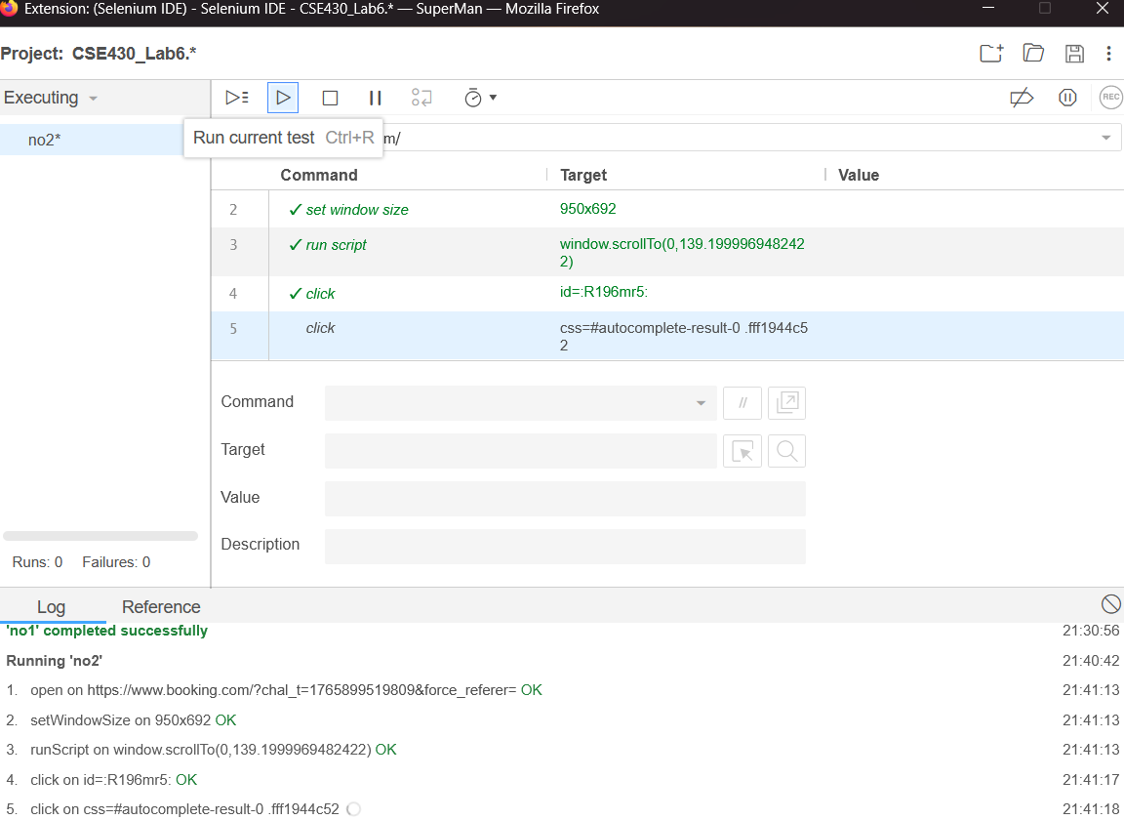

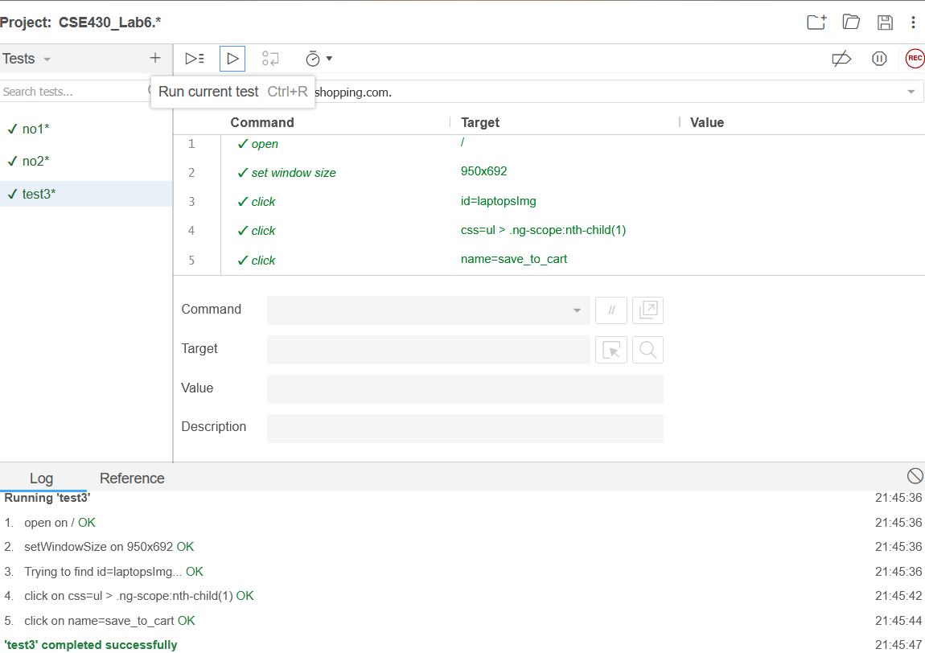
3. Product Add-to-Cart Test

4. Responsive Navigation (W3Schools)

